STP Test Case Report
STP Test Case Report
STP Test Case # ST-2
Requirements Tested: FR-4.2: The system shall flag a weekly report as incomplete if any required field is empty or null.
Build/Release #: v0.1.0_20260304

Setup:
1. Open the Chrome browser on Mac OS.
2. Navigate to front-facing Moxie server (http://moxie.cs.oswego.edu:7000/)
3. Log into the system (future feature: Google OAuth).
4. Execute test.

Execution:
1. Navigate to the Worklog form.
2. Leave at least one required field empty (tested with the ‘collaborators’ section left blank).
3. Attempt to submit the report.
4. Return to the Student Home Page.
5. Observe the report status and any system feedback.

Expected Result:
- The system should flag the report as incomplete.
- An error message (e.g., red field highlight) should appear on the empty required field.
- The report should NOT be submittable until all required fields are filled in.

Actual Result:
- The system successfully flagged most required fields as incomplete with visual error feedback.
- However: The collaborators section did not flag as incomplete when left empty; it allowed submission without it.

Screenshot:
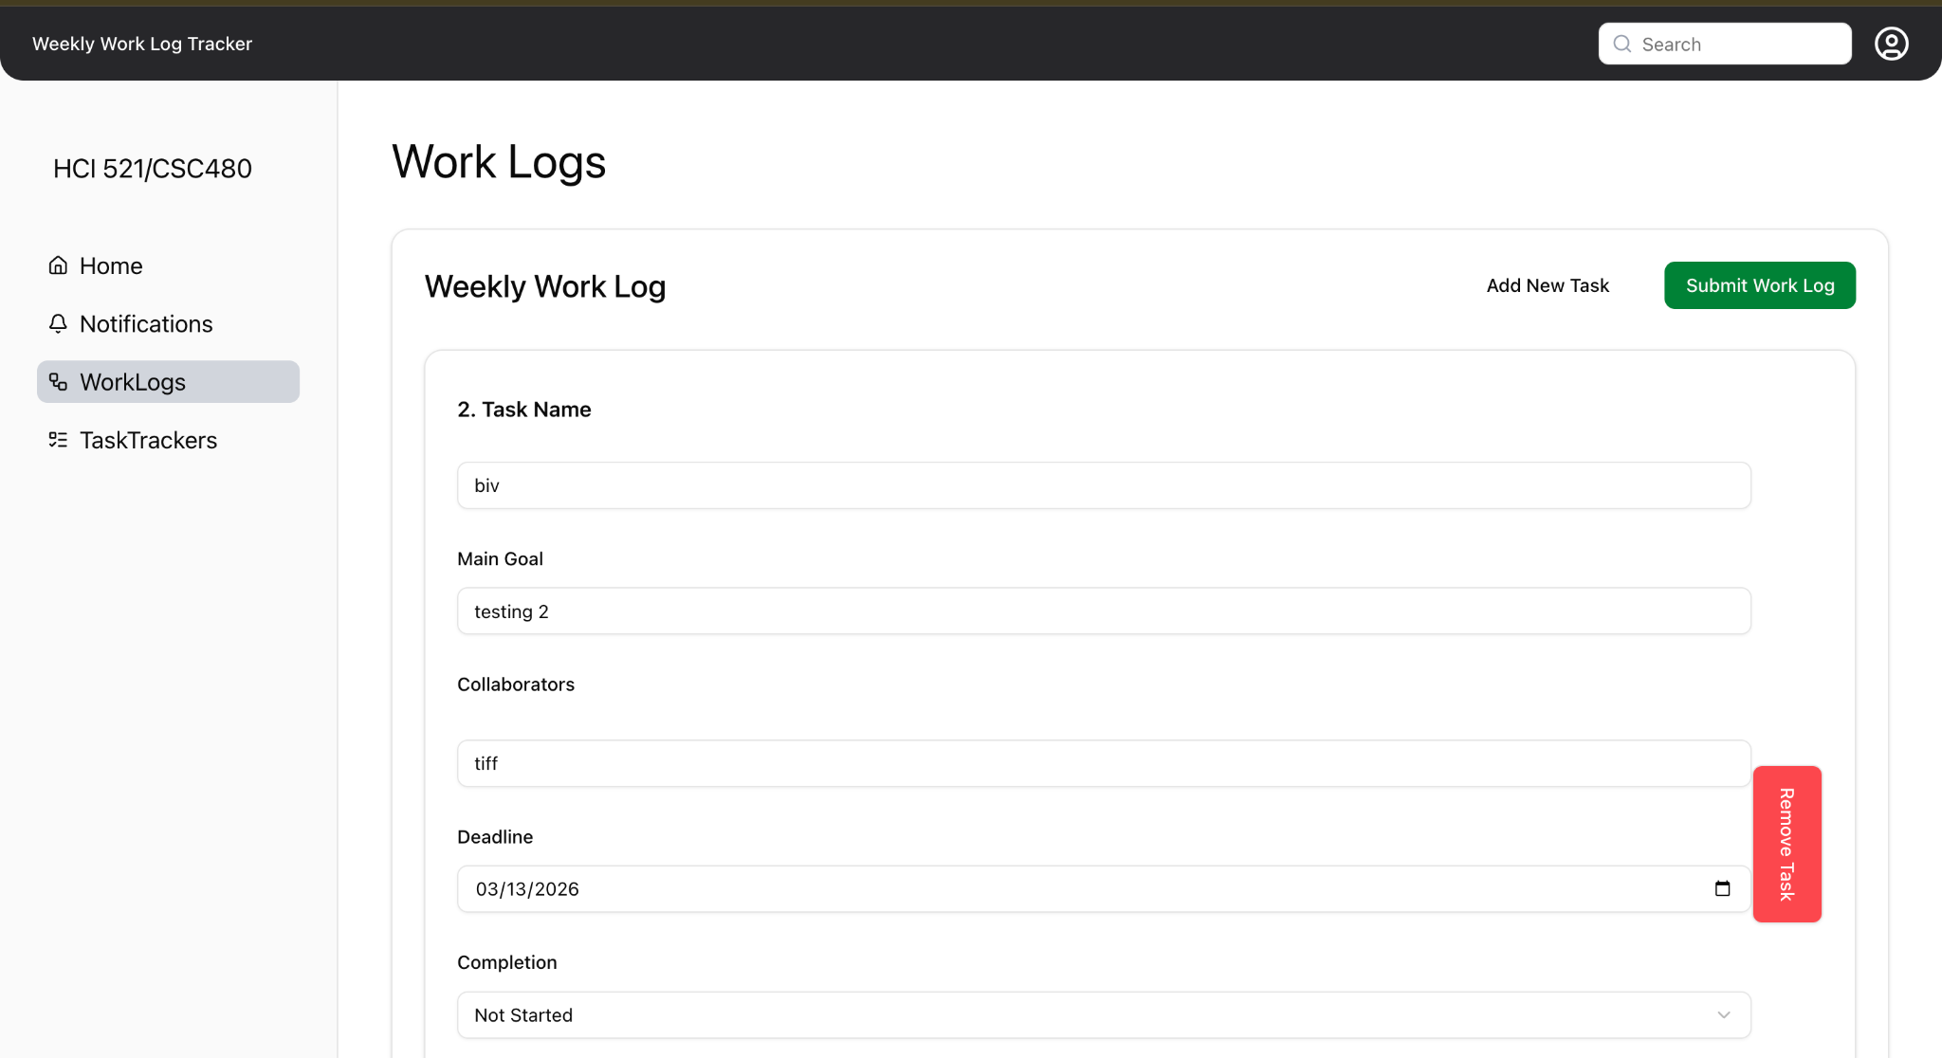
Fig (1.0): There should not be any error message when all fields are filled out.

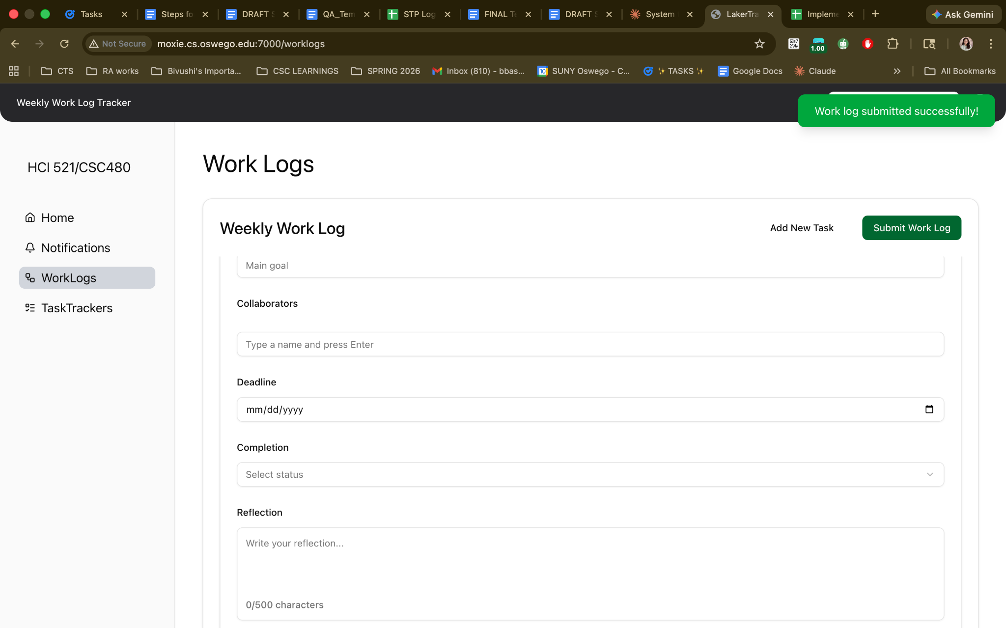

Fig. (1.1): The collaborators section was not flagged as incomplete when left empty; it allowed submission without it.
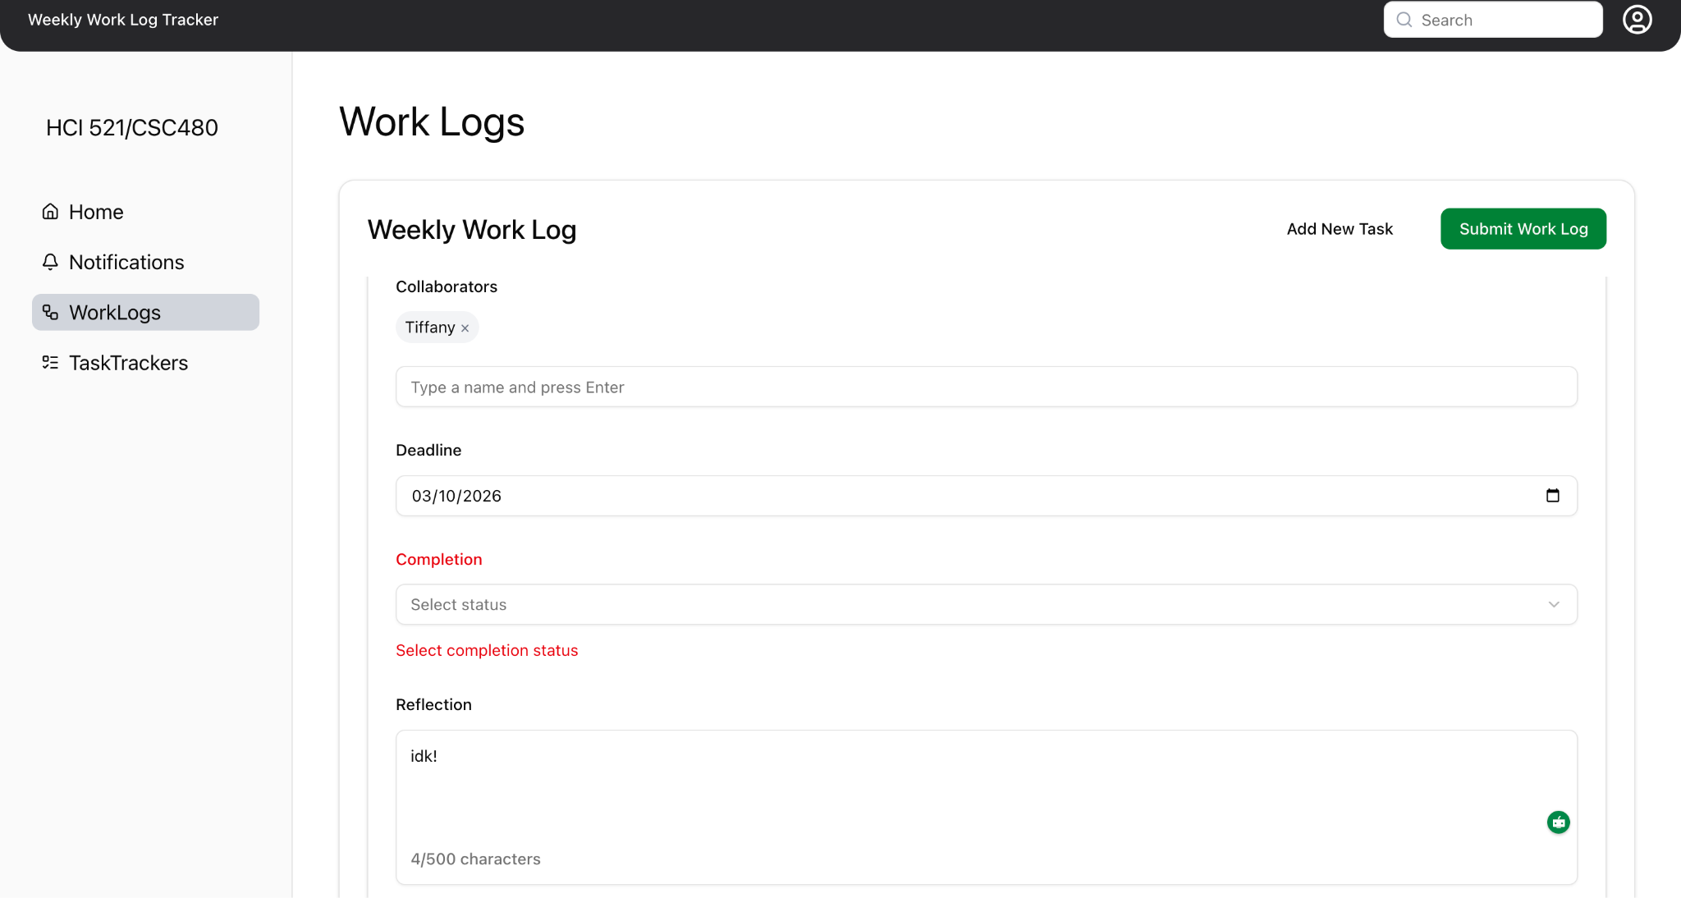
Fig: (1.2) : The system flags the report as incomplete, highlights empty required fields in red, and prevents submission until all required fields are filled in.

Determination: Test partially successful, FAILED on collaborators section

STP Test Case # ST-2
Requirements Tested: FR-4.3: The system shall prevent incomplete weekly reports from being marked as complete.
Build/Release #: v0.1.0_20260304

Setup:
1. Open the Chrome browser on Mac OS.
2. Navigate to front-facing Moxie server (http://moxie.cs.oswego.edu:7000/)
3. Log into the system (future feature: Google OAuth).
4. Execute test.

Execution:
- Navigate to the Home Page and look into the ‘Task Tracker’ section.
- Navigate to the Notifications Page and look into the ‘Task Tracker’ section
- Attempt to change the report status from In Progress to Complete.
- Observe whether the system prevents or allows the status change.

Expected Result:
- The system should prevent the report from being marked as complete.
- A status change option (e.g., dropdown, button) from In Progress → Complete should be blocked or disabled.
- An error or warning message should notify the user the report is incomplete.

Actual Result:
- There is no option available to change or select the report status from In Progress to Complete.
- The only available action is to highlight/copy the current status; no status change functionality exists in the UI.
- Cannot confirm if the system prevents the action because the feature does not appear to be implemented.

Screenshot:
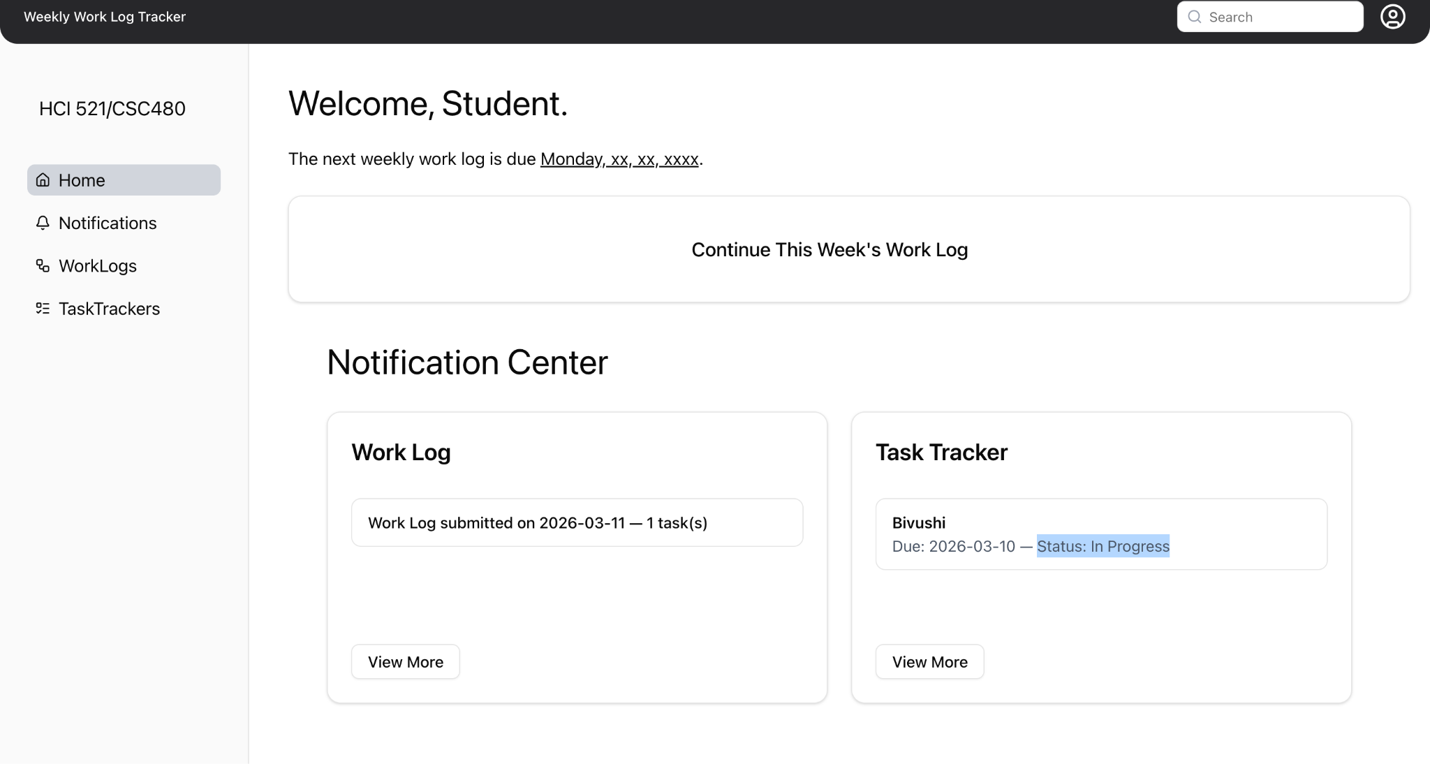

Fig. (2.0): The ‘status’ could only be highlighted and not changed from the ‘Home Page.'

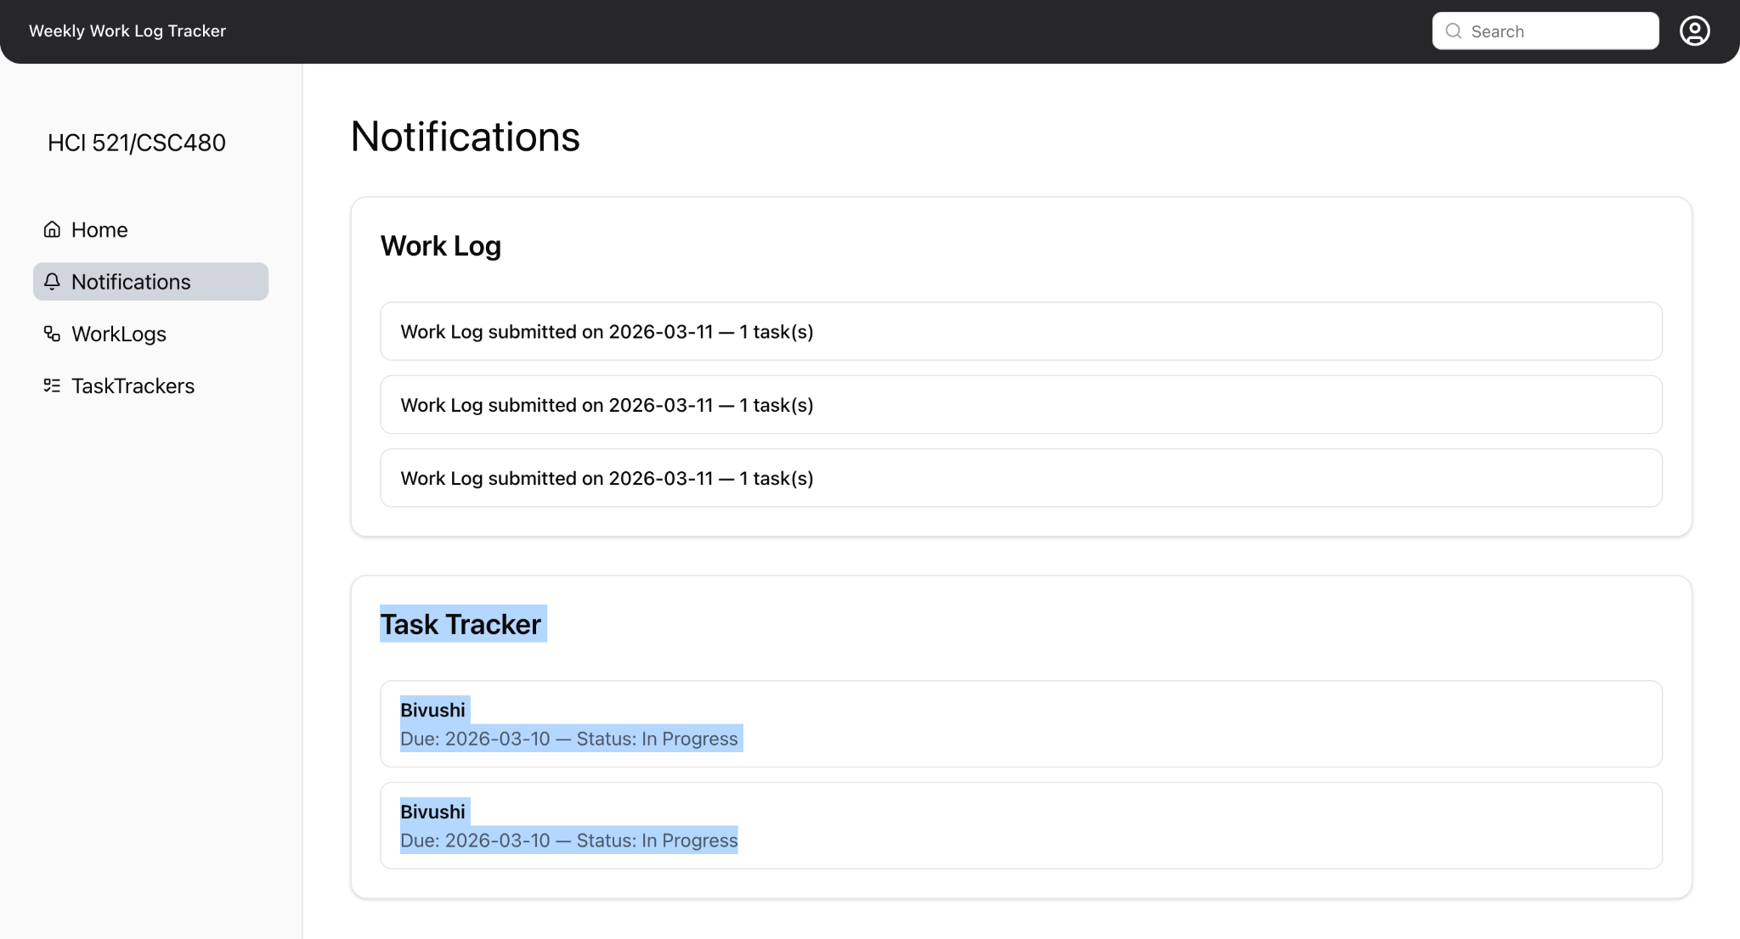
Fig (2.1): The ‘status’ could only be highlighted and not changed from the ‘Notifications Page.'

Determination: Test Incomplete; Status change functionality not found in UI.

Bug/Defect Report
Bug/Defect Report
Bug/Defect # Defect-1
Severity: High
STP Test Case #: ST-2
Build/Release #: v0.1.0_20260304

Steps During Test:
- Open Chrome browser on Mac OS
- Navigate to Moxie homepage (http://moxie.cs.oswego.edu:7000/)
- Navigate to the Weekly Worklog form
- Filled in all required fields EXCEPT the Collaborators section (left blank)
- Attempted to submit the report
- System allowed submission without flagging the Collaborators field as incomplete

Description:
During ST-2 testing of FR-4.2, the system correctly flagged most empty required fields as incomplete (red field highlighting and error indicators). However, the ‘Collaborators’ section was not flagged when left empty, and the system allowed the report to be submitted without it. This is a failure of FR-4.2 specifically for the Collaborators field.

Potential Cause (if known):
xxx

Screenshots of Error:


